Sample Checklist for AppWorks Package Review:

Item | Check
manifest.xml | Proper structure, vali  d references to artifacts
Entity definitions | Field naming, types, constraints, default values
Forms | UI bindings, visibility rules, localization support
Relationships | Proper use of associations, ownership, and lookups
File structure | Required folders (META-INF, Artifacts, etc.) present
App deployment config | Correct namespace, versioning, application metadata
Resource files (images, etc) | Used and referenced properly in forms or branding

code review of manifest.xml from an OpenText AppWorks package
manifest.xml Review Checklist
Check | Description
Root tag manifest | Must exist and be well-formed
name, namespace, version | Should be defined at root level
Artifact references | Should point to valid entities/forms/etc.
Missing or duplicate tags | Should be flagged
Use of consistent casing | CamelCase or PascalCase best practices
Structure & indentation | Should be readable and hierarchical

code review of an AppWorks Entity Definition using Python, I can help analyze the XML or text structure of a .entity file. These files usually define:
- Entity name and namespace
- Attributes (fields)
- Relationships
- Validation rules
- Display options
code review of OpenText AppWorks forms. These are typically XML files (sometimes with a .form extension) that define how entities are displayed and interacted with in the UI
Element | Checks & Suggestions
<form> root | Must have valid name and entity attributes
Field bindings | Must reference existing entity attributes
Layout structure | Logical use of <rows>, <columns>, etc.
Validation rules | Presence of required attributes
Visibility/Read-only logic | Well-structured expressions and conditions
Label & translation usage | Labels should not be hardcoded if localization is needed
Duplicate controls | Avoid reusing the same field multiple times unnecessarily
Usability | Good grouping, ordering, default values
code review of relationships in an OpenText AppWorks .entity file.
Relationships in AppWorks define how one entity connects to another (e.g., one-to-many, many-to-one). These are typically declared within the <relationships> section of the entity definition XML.
Checkpoint | Description

Relationship name | Should be unique and meaningful

Type of relationship | Must be valid (association, aggregation, composition)

Target entity | Must be specified and valid

Cardinality | Must make sense (one, many)

Inverse relationship | Optional but useful for navigation

Navigation settings | Should be consistent with UI needs

Referential integrity | Ensure proper cascading behaviors if required
When it comes to reviewing the file structure of an OpenText AppWorks package, there are a few best practices and organizational rules to follow. Proper file structure ensures the package is well-organized, maintainable, and adheres to OpenText’s standards.
Component | Checkpoints & Considerations

Root directory | Must contain the necessary directories like META-INF, Artifacts, Resources, etc.

META-INF folder | Must contain important files like manifest.xml, and optionally *.properties for metadata

Artifacts folder | Should include all the entities, forms, workflows, scripts, etc. Each artifact should be in the correct subfolder (like Entities, Forms, etc.)

Resources folder | Should contain media (images, icons) and localization files (e.g., *.properties)

Naming conventions | Directories and files should follow naming conventions (CamelCase or PascalCase depending on your team's style guide)

Empty files | Avoid creating empty folders or files unless there’s a valid reason (e.g., placeholder for future additions)

Package versioning | The folder structure should support versioning where necessary (e.g., include version numbers in file names or directories for backward compatibility)
- Required Folders:
  - Checks for the presence of META-INF, Artifacts, and Resources folders.
- Artifacts Subfolders:
  - Ensures Entities, Forms, Workflows, and other expected folders are inside Artifacts.
- Manifest File:
  - Ensures the manifest.xml file is located in META-INF.
- Resources Folders:
  - Checks for common subfolders like Images and Localization within Resources.
The App Deployment Configuration in OpenText AppWorks is critical to ensure that the application is deployed correctly and adheres to all required configurations for a smooth operation. Typically, deployment configurations are specified in the manifest.xml, but there may be additional configurations or metadata in other files like *.properties or within the META-INF directory.

Key Areas to Review in App Deployment Configuration
- manifest.xml Configuration
  - The manifest.xml contains key metadata such as:
    - name, namespace, version, and description
    - Artifact references (Entities, Forms, Workflows, etc.)
    - Versioning strategy
    - Namespace and package dependencies
    - Supported environments (if applicable)
- Environment Configuration
  - Deployment settings for different environments (e.g., production, staging).
  - Connections to external systems or databases (e.g., API endpoints, authentication services).
  - Configuration of integrations like single sign-on (SSO), cloud services, etc.
- User and Role Configurations
  - Ensure roles and permissions are properly defined for each artifact and user type.
  - Validate that these configurations are aligned with deployment needs.
- Versioning and Backward Compatibility
  - Ensure that the deployment configuration supports backward compatibility.
  - Properly versioned files and resources to allow for seamless upgrades or patches.
- Custom Deployment Configurations
  - Custom properties or configurations may exist (e.g., custom .properties files for database connections or third-party services).
  - Ensure these configurations are dynamic (adjustable per environment) and well-documented.

Review Checklist for App Deployment Configuration
Item | Checkpoints to Review
Deployment Section (<deployment>) | Must exist
Environments (<env>) | Valid environment names (production, staging, etc.)
Database Configurations | Proper URL, username, and password for each environment
API Endpoints | Correct URLs and keys for each environment
SSO Configurations | SSO provider set for each environment (if applicable)
Missing Elements | Check if any required sections (database, API, SSO) are missing
Versioning | Ensure that version tags are updated and correct for deployment
When reviewing resource files like images, icons, and other static assets used in an OpenText AppWorks application, there are several best practices and things to check to ensure optimal organization, performance, and maintainability.
Key Areas to Review in Resource Files
- Folder Structure
  - Proper organization of resources into subfolders (e.g., Images, Icons, Localization).
  - Use of descriptive folder names (e.g., logos, user-images, icons).
  - Consistent naming conventions for image files (e.g., icon_user.png, background_header.jpg).
- File Types and Size Optimization
  - Use of appropriate image formats (e.g., PNG for transparent backgrounds, JPEG for high-quality images with small file sizes, SVG for scalable graphics).
  - Image size optimization (e.g., images shouldn’t be larger than necessary for the UI to reduce load times).
- Responsive Design Considerations
  - Multiple image sizes for different screen resolutions (e.g., icon_48x48.png, icon_72x72.png).
  - Retina display and responsive assets for different devices (i.e., 2x, 3x versions).
- Naming Conventions
  - Consistent and descriptive names (e.g., logo_main.png, icon_settings.png).
  - Avoid spaces, special characters, and upper-case letters in file names to prevent compatibility issues.
- Localization
  - If the app supports multiple languages, ensure image or asset localization is taken into account (e.g., different logos for different regions, localized icons).
  - Localization files in Resources/Localization/ (e.g., en-US.properties, fr-FR.properties).
- Image Usage in Forms or UI
  - Ensure the images are being used correctly within the forms and UI (e.g., correct image paths, no broken links).
  - Check for unused or orphaned images in the Resources folder.
- Accessibility
  - Ensure images have alternative text descriptions where required.
  - Icons should have semantic meaning (e.g., using aria-labels for buttons).
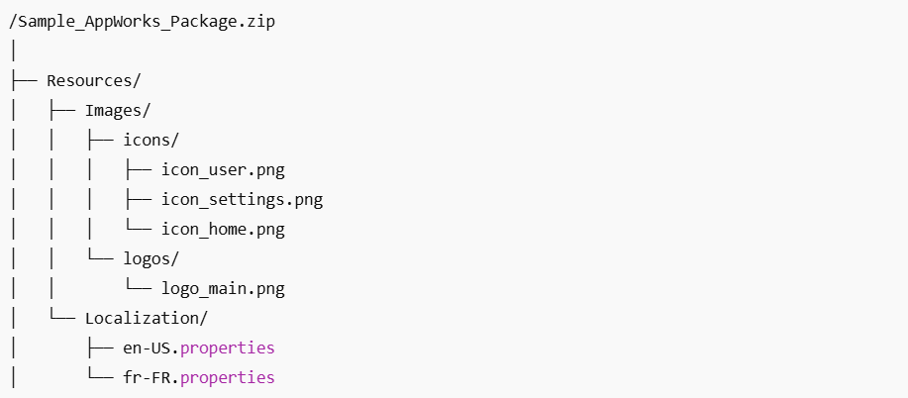
Review Checklist for Resource Files
Item | Checkpoints to Review

Folder Organization | Ensure Images and Localization folders exist and are well-organized

Image Naming Conventions | Lowercase filenames, avoid spaces or special characters

File Types and Sizes | Use appropriate formats (PNG, JPG, SVG) and optimize images for size

Responsive Assets | Include multiple versions for different screen resolutions (e.g., icon_48x48.png, icon_72x72.png)

Localization | Ensure proper localization files (e.g., en-US.properties, fr-FR.properties)

Orphaned Files | Remove any unused image files or assets

Accessibility | Ensure icons have alternative text (via tooltips, etc.) if needed

